DOCUMENT SUBMISSION PROCEDURE FOR MAGISTRATE
(FAMILY & CIVIL)

As of June 1, 2019 all proposed
Report and Recommendations of the Magistrate, Orders on Report and
Orders of Referral must be submitted electronically.
Hard copy paper submissions are no longer accepted.
CONTACT INFORMATION | Electronic submission of documents only:  cha-magistrate@ca.cjis20.org  This email address is for electronic submission of documents only. Any additional correspondence should be limited to information pertaining to the filing of any attached documents.
 | General procedure and scheduling questions: ksandrock@ca.cjis20.org
- DOCUMENT FORMAT  - REPORTS AND ORDERS | - Must be Microsoft Word document type “.docx”
- EXHIBITS | - Preferred: Microsoft Word document type “.docx”  Accepted: PDF or Excel document types
- ORDER FORMAT
- MAGISTRATE’S REPORTS
- JUDGE EVANS’ ORDERS
- JUDGE GENTILE’S ORDERS | - 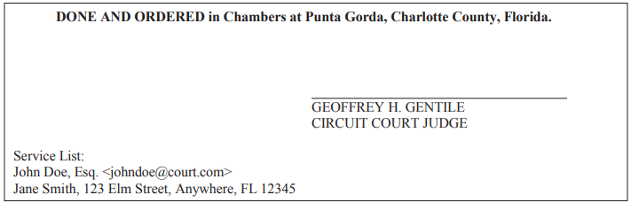
- COMMUNICATION WITH OPPOSING PARTIES  - DESIGNATION OF EMAIL ADDRESS FORM | - Designation of email address form-family  Designation of email address form-civil
- NO DESIGNATION OF EMAIL ADDRESS | - Stamped addressed envelopes must be furnished by the attorney who submitted the proposed report and recommendations of the magistrate and orders on report.
- EMAILING ORDERS  - DOCUMENTS | - You must save report and recommendations of the magistrate and orders on report as two separate documents. Be consistent with the saved document names.
- SUBJECT LINE  (ALL PARTIES E-SERVED) | - All parties e-served:  Family matters email subject line must be:  “FAM – R&R/Order – Smith v. Doe/19-123DR”  Civil matters email subject line must be:  “CIV – R&R/Order – Smith v. Doe/19-123CA”
SUBJECT LINE  (ANY PARTIES SERVED BY HARD COPY) | Any parties served by hard copy:  Family matters with forthcoming envelopes subject line must be:  "FAM – R&R/Order – Smith v. Doe/19-123DR (envelopes submitted)"  Civil matters with forthcoming envelopes subject line must be:  "CIV – R&R/Order – Smith v. Doe/19-123CA (envelopes submitted)"
- ENVELOPE SUBMITTAL | - Report and recommendations of the magistrate and orders on report will not be processed until the appropriate envelopes are received. The attorney’s office submitting the documents must include the name and address of those persons to be served by hard copy, in the body of the e-mail when submitting the proposed report and recommendations of the magistrate and orders on report.
- REJECTED DOCUMENTS | If there is an error in your submission, you will receive a rejection email that contains an excerpt from these instructions with the appropriate specific information explaining the error highlighted. Please read the error message and make appropriate revisions. The judicial assistant will not follow up on rejected documents. It is your responsibility to revise and resubmit.

